Katherine Barbarite of Whispering Hooves
“Partnership & Confidence Building Horsemanship”
Presents
“Structured Foundation”
At

Santori Ranch
955 W. Road 2 North
Chino Valley, Arizona 86323

December 15 , 2018

Katherine teaches a straight forward set of exercises that aids in the development of a
calm confident horse and rider. No matter the skill level or discipline, these steps
remove fear and resistance, elevating trust, communication and bond. Understand the
importance herd structure and leadership to enhance safety and promote growth.
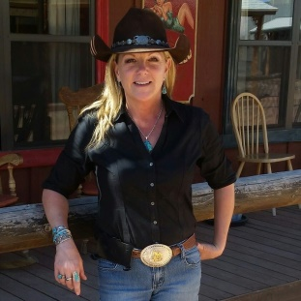
Learn why bad timing and poor releases lead to unhappy horses. Become one with
your horse by practicing and mastering the “Lost art of Horsemanship”. Most of all,”
become more than a passenger become a partner”.
“Ask… Wait… then Give for Results”
“Connect with the mind and feet will follow---------Katherine Barbarite

- Certified Horse Trainer
- Certified Horsemanship Association Riding Instructor (Western/English)
- Topics:
During the workshop you will be working with your horses from the ground to saddle. Connecting and building a true partnership and heighten your confidence, allowing you and your horse to set up for success. Confront and overcome anxiety and fear that is caused by the unknown, increasing your confidence by understanding the mechanics of the four legs underneath you. Understand the “why, how and when” of communication when in the saddle. This will graceful improve your timing, finesse, balance and feel.

Cost: $ 165 per person 1-Day hands on workshop 10am-3pm

Details: Please arrive ½ hour early before clinic,
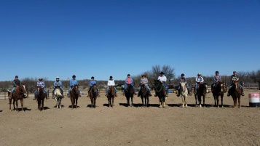
Bring properly fitted saddles, pads, bridles., Nylon rope halter w/ 12’ lead.

Contact: Katherine Barbarite of Whispering Hooves
www.whisperinghooves.com kathy@whisperinghooves.com
(631)764-7515
*International equine presenter and lecturer.
*Certified Horse Trainer
*Certified Horseman’s Assoc. Riding Instructor (Western & English)
*Author of Book: Whispering Hooves the Missing Art of Horsemanship
*Featured in: Trail Rider Magazine: Phoenix Times: Tito Times (Costa Rica): The Times Independent (Moab Utah), Syracuse Times , (NY) Performance Horse Digest, Tri-State Horse, Country Folks Mainstream(NY)*Clinician/Demonstrator at NE Equine Expo; Equine Affaire; Islip Horseman’s Assoc.; East End Livestock Horseman’s Assoc.; National Day of the American Cowboy (NY); Malibu Dude Ranch (PA); Kay El Bar Ranch (AZ); King Mountain Ranch (CO); White Stallion Ranch (AZ); De La OSA (AZ); Sunrise Farm (MD); Las Cascadas (MX); Barking Horse Farm (Costa Rica); Rancho Tranquilo (Costa Rica); Todd Mountain Ranch (BC) Cimarron Ranch (NY), Horse World Expo (PA), Equifest (NY), Certified Horseman’s Association International Conference(NY), Tombstone monument (AZ), Quiet Creek Stables (NJ), North folk Stables (NY).,NY Horse Center (NY).

